**AI-900T00-A Labs**

Lab-1 -[Explore machine learning scenarios](https://msle.learnondemand.net/Lab/77500?instructionSetLang=en&classId=720986)

Prediction of house rent based on regional postcode and property features(size,rooms)

Based on sample data given it is predicting the rent of an property

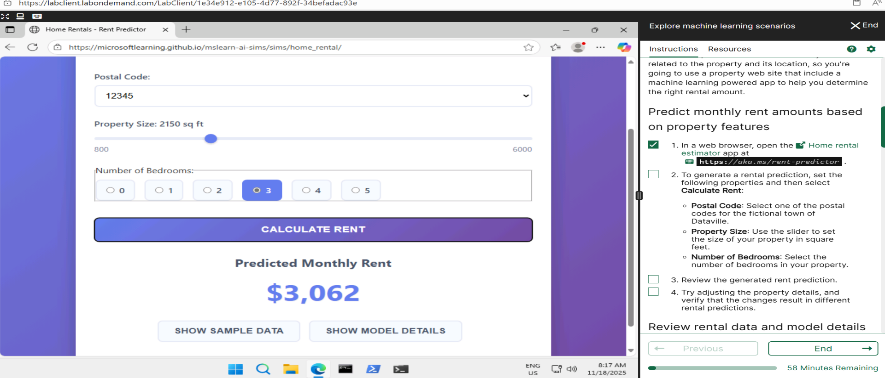

Sample data prediction

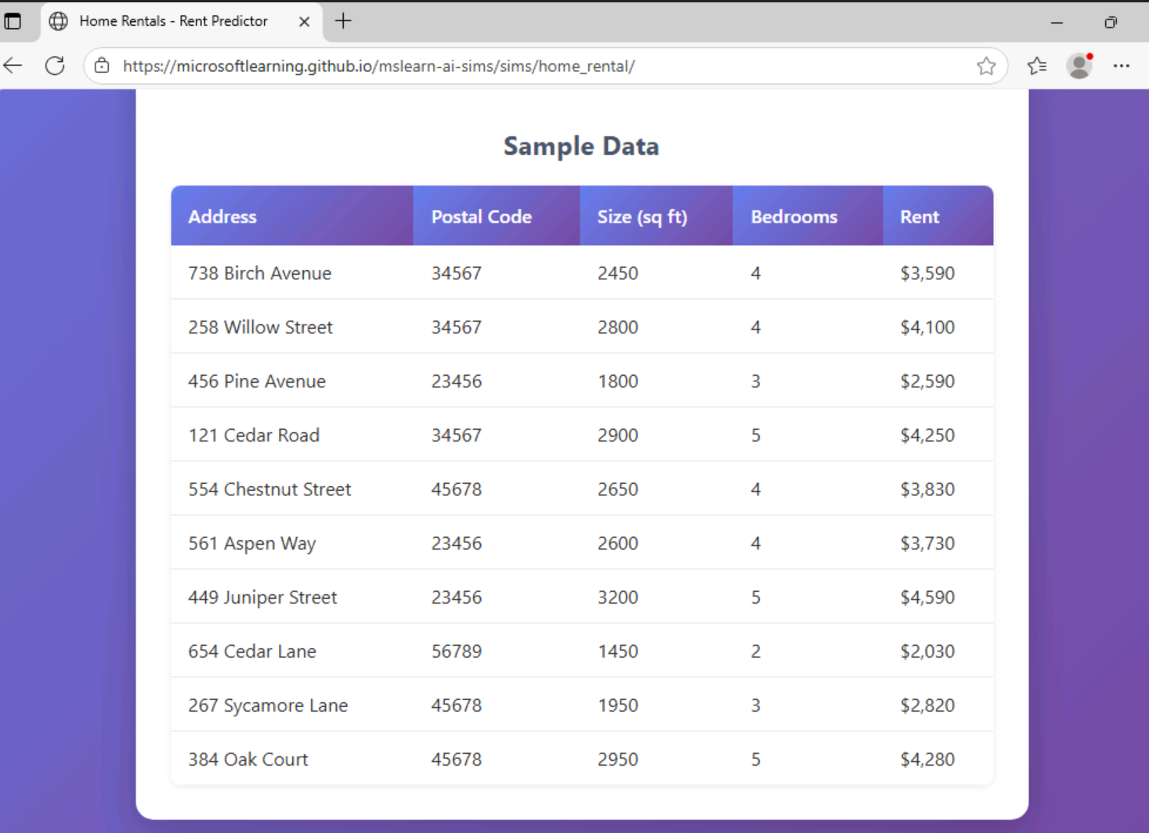

Details of Model data

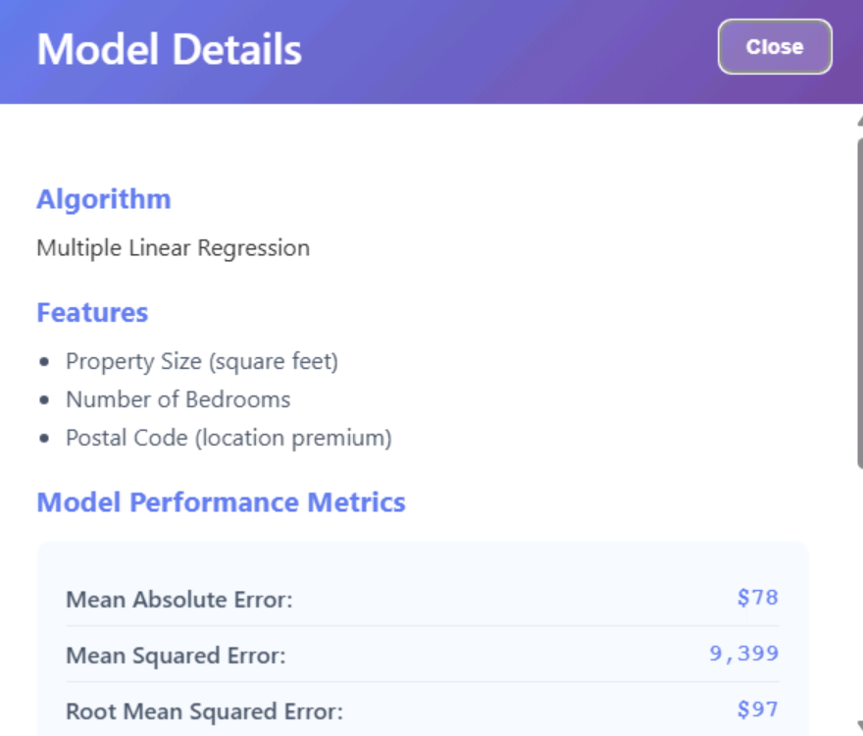

Predicted wheat through seeds

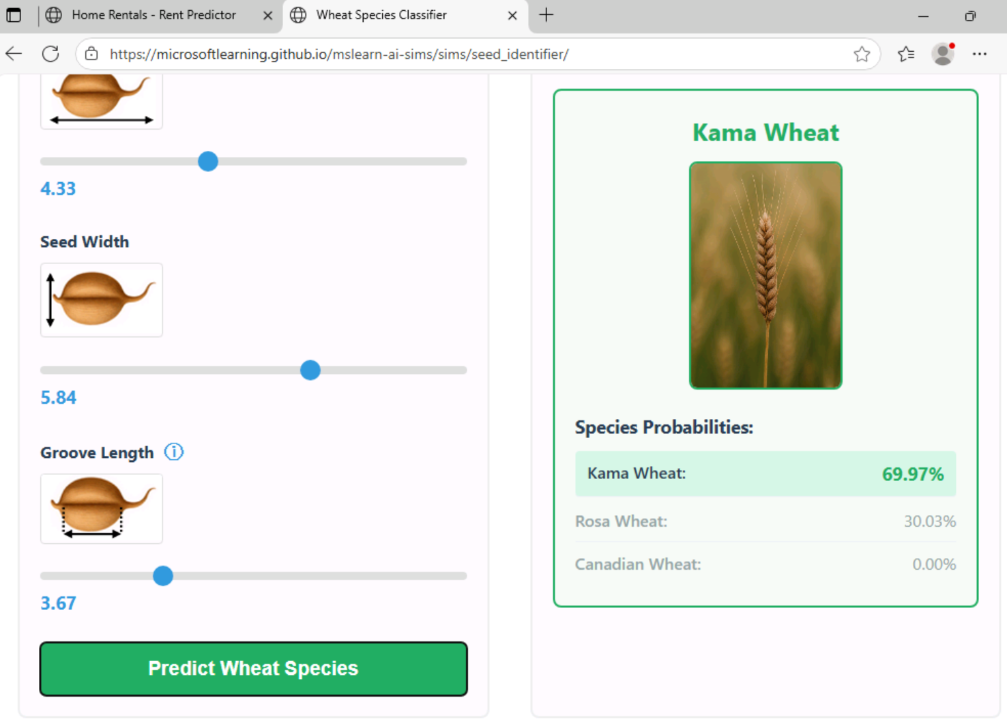Sample data of wheat predictor

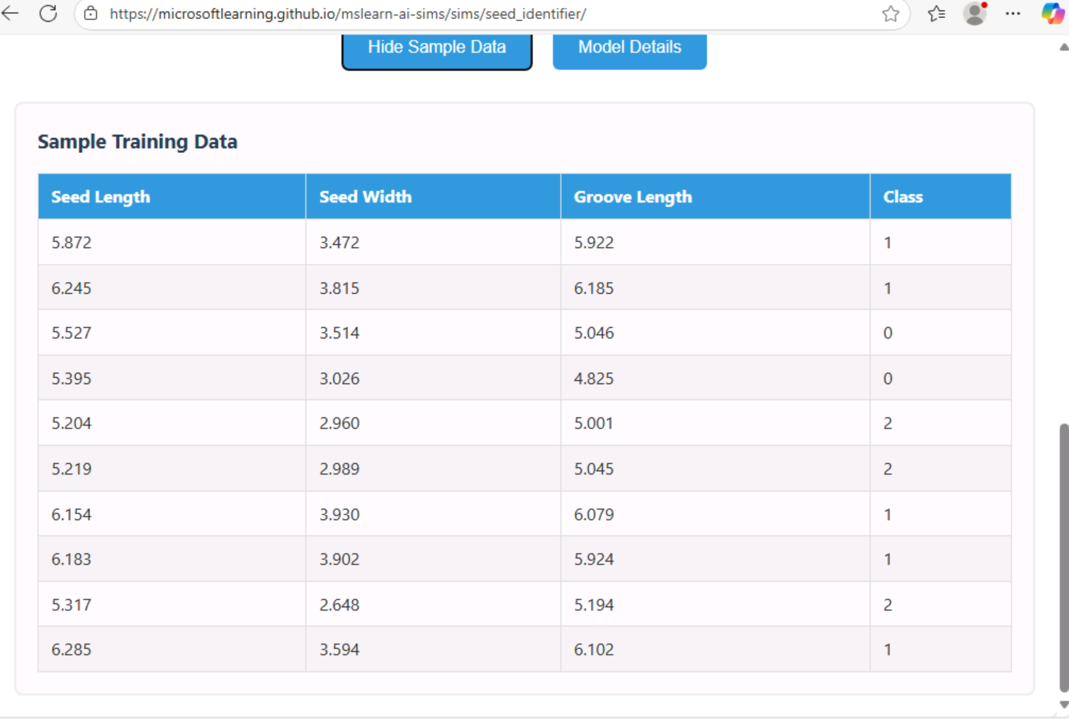Model details

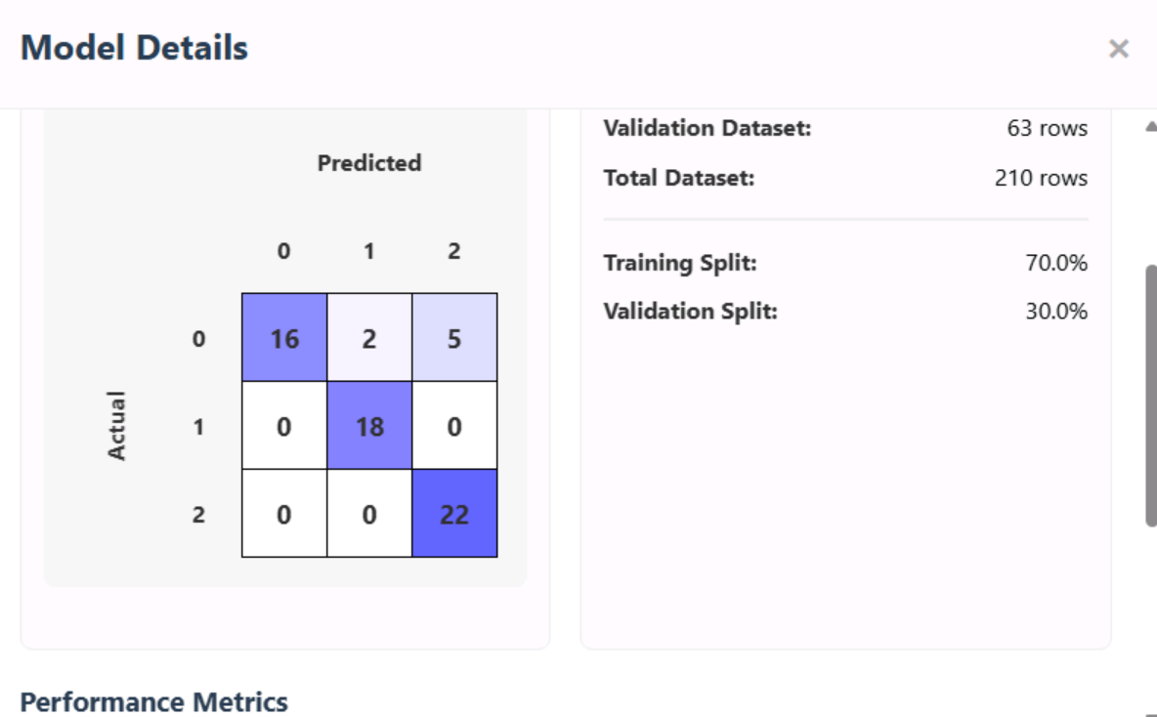Customer segment before analysis

After analysis

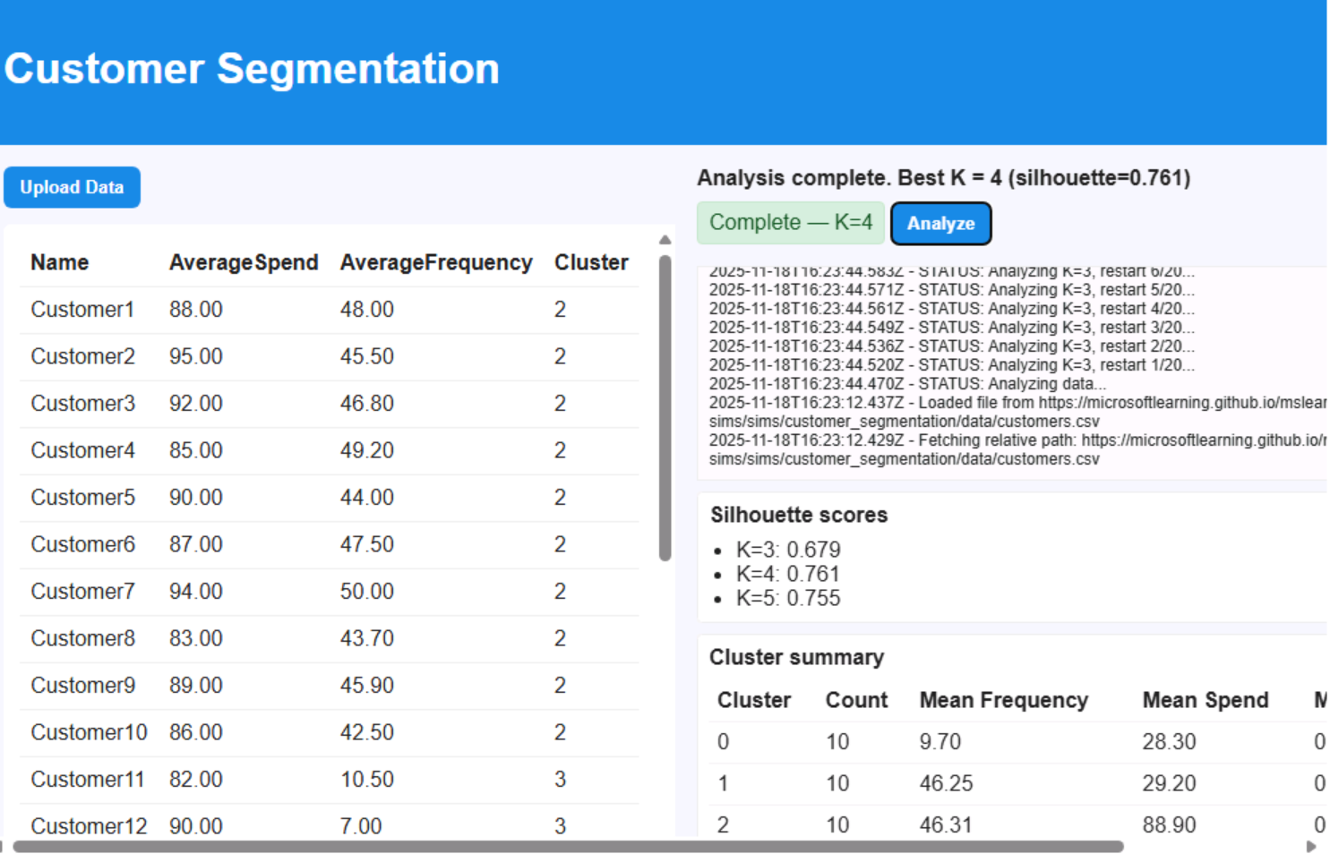

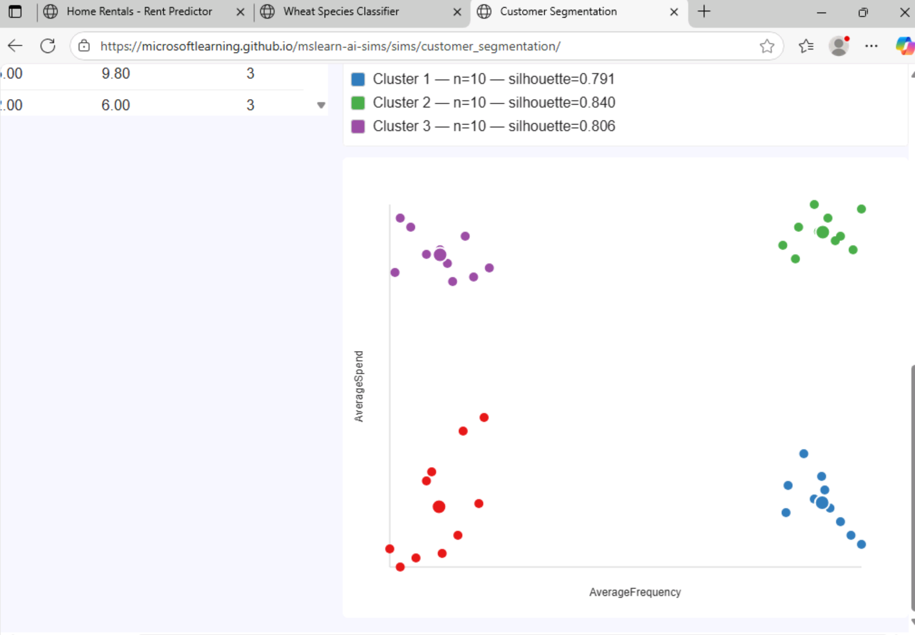

Lab-2 - [Explore Automated Machine Learning in Azure Machine Learning](https://msle.learnondemand.net/Lab/77505?instructionSetLang=en&classId=720986)

Prediction of Ice cream sales ,Based on the data ML analysis the ice creame sales 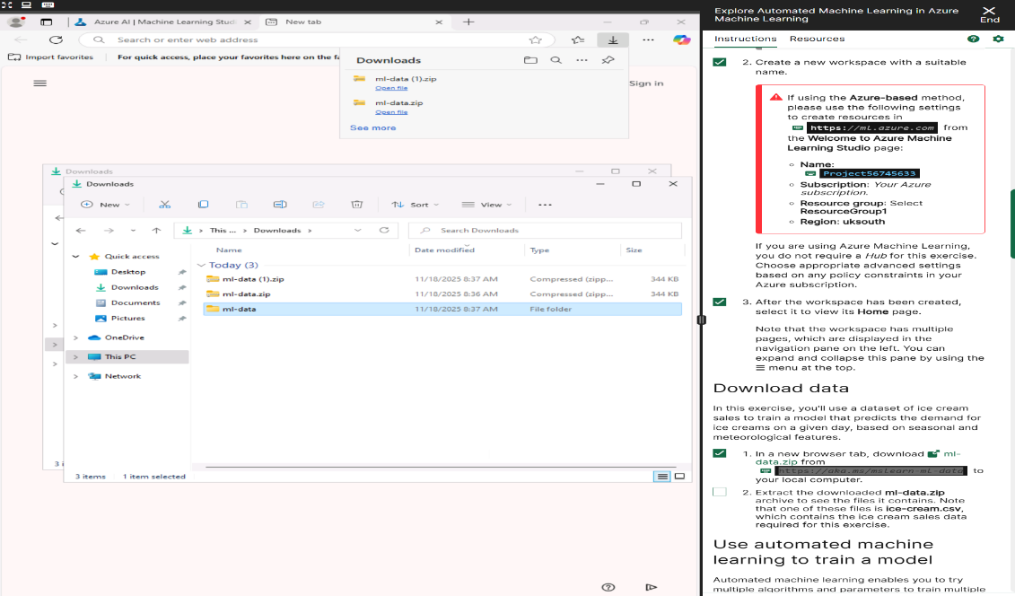

Creating automated ML file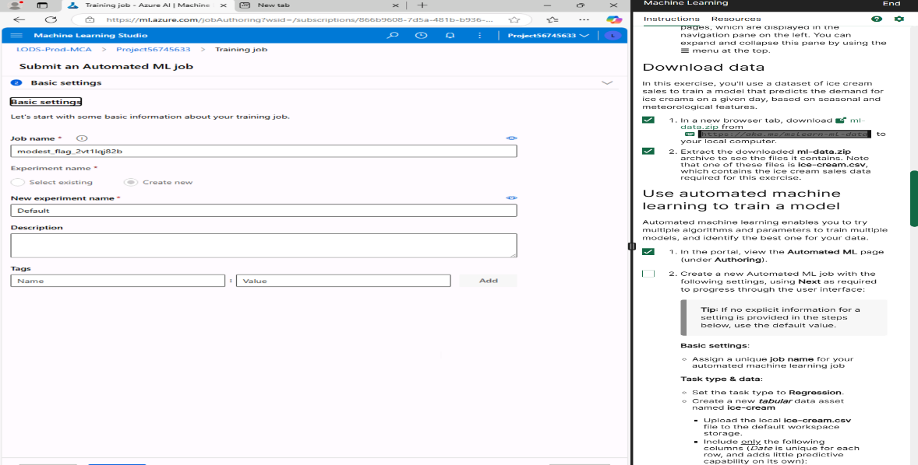C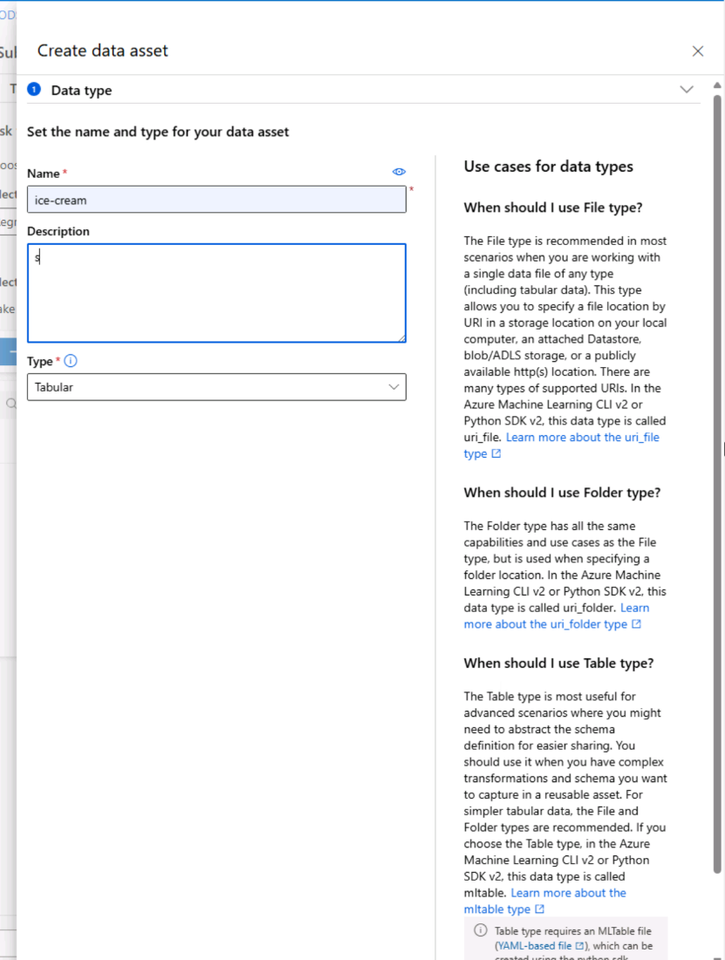

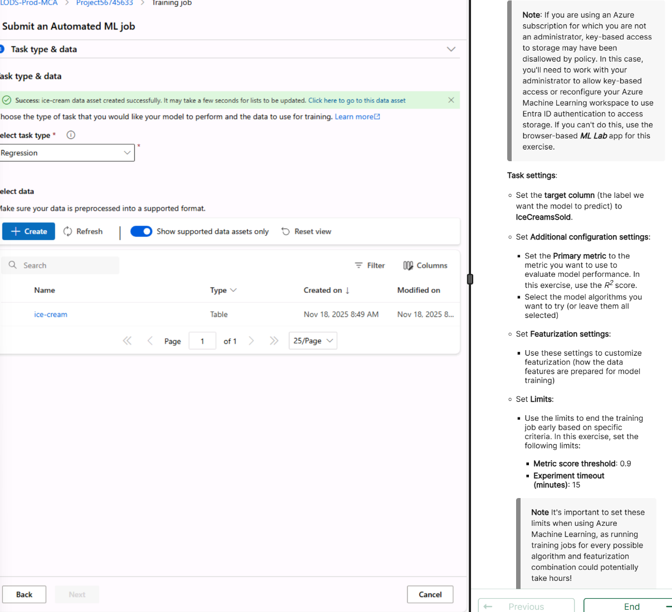

Lab 3 -[Explore a generative AI agent scenario](https://msle.learnondemand.net/Lab/77501?instructionSetLang=en&classId=720986)

Build an agent to about the expenses in particular city

Based on the data ML analyses and provide us the Lining cost in a particular city

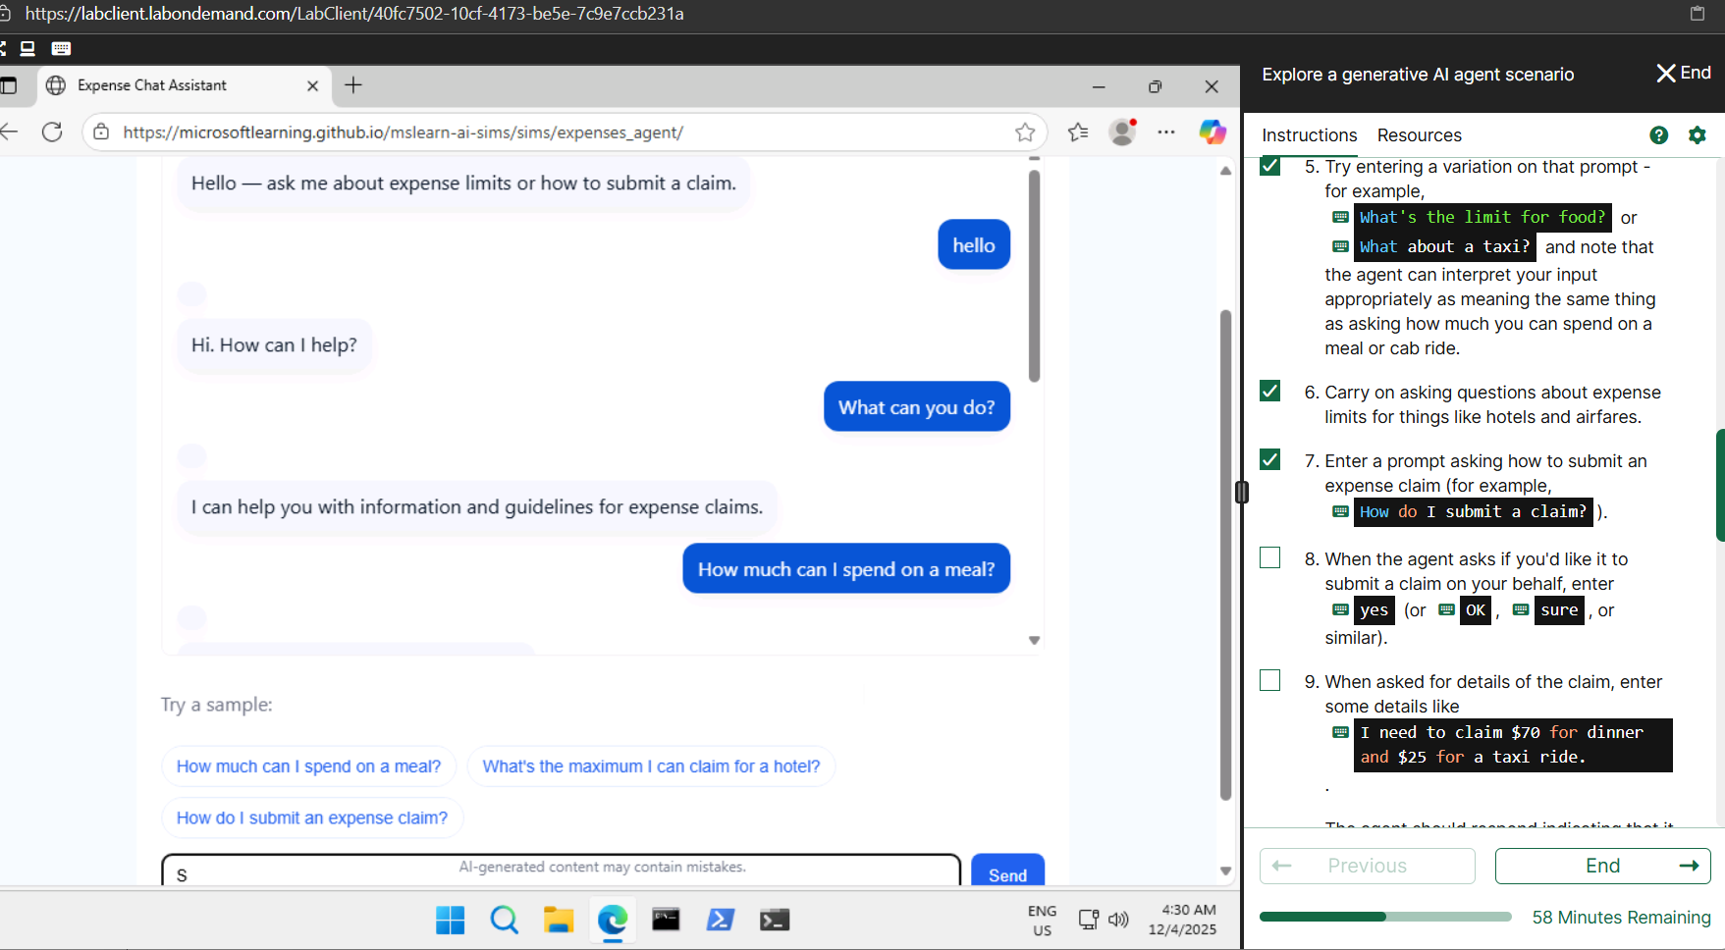

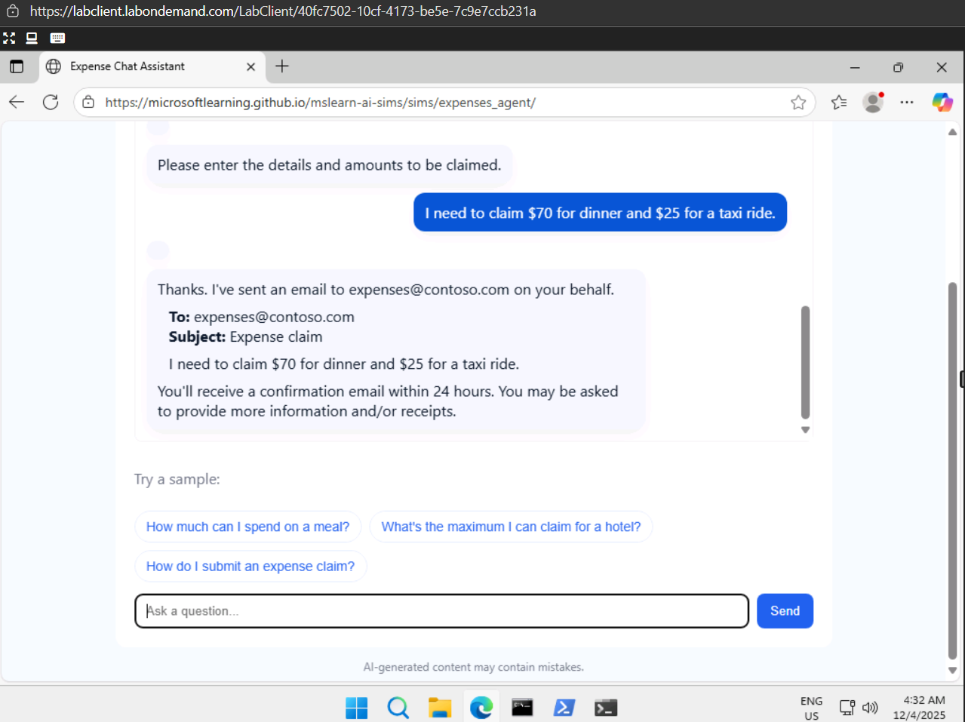

Lab 4 -[Explore generative AI in Azure AI Foundry portal](https://msle.learnondemand.net/Lab/77495?instructionSetLang=en&classId=720986)

Selecting resume through generative AI

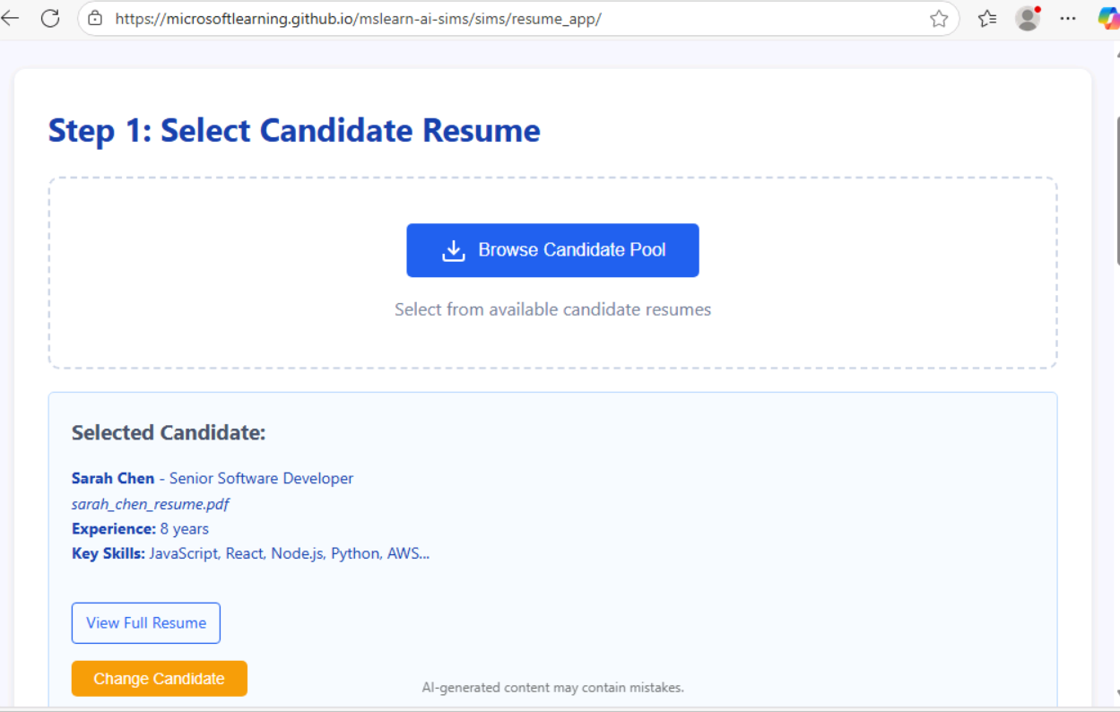

AI Analyses and present the skills with percent   
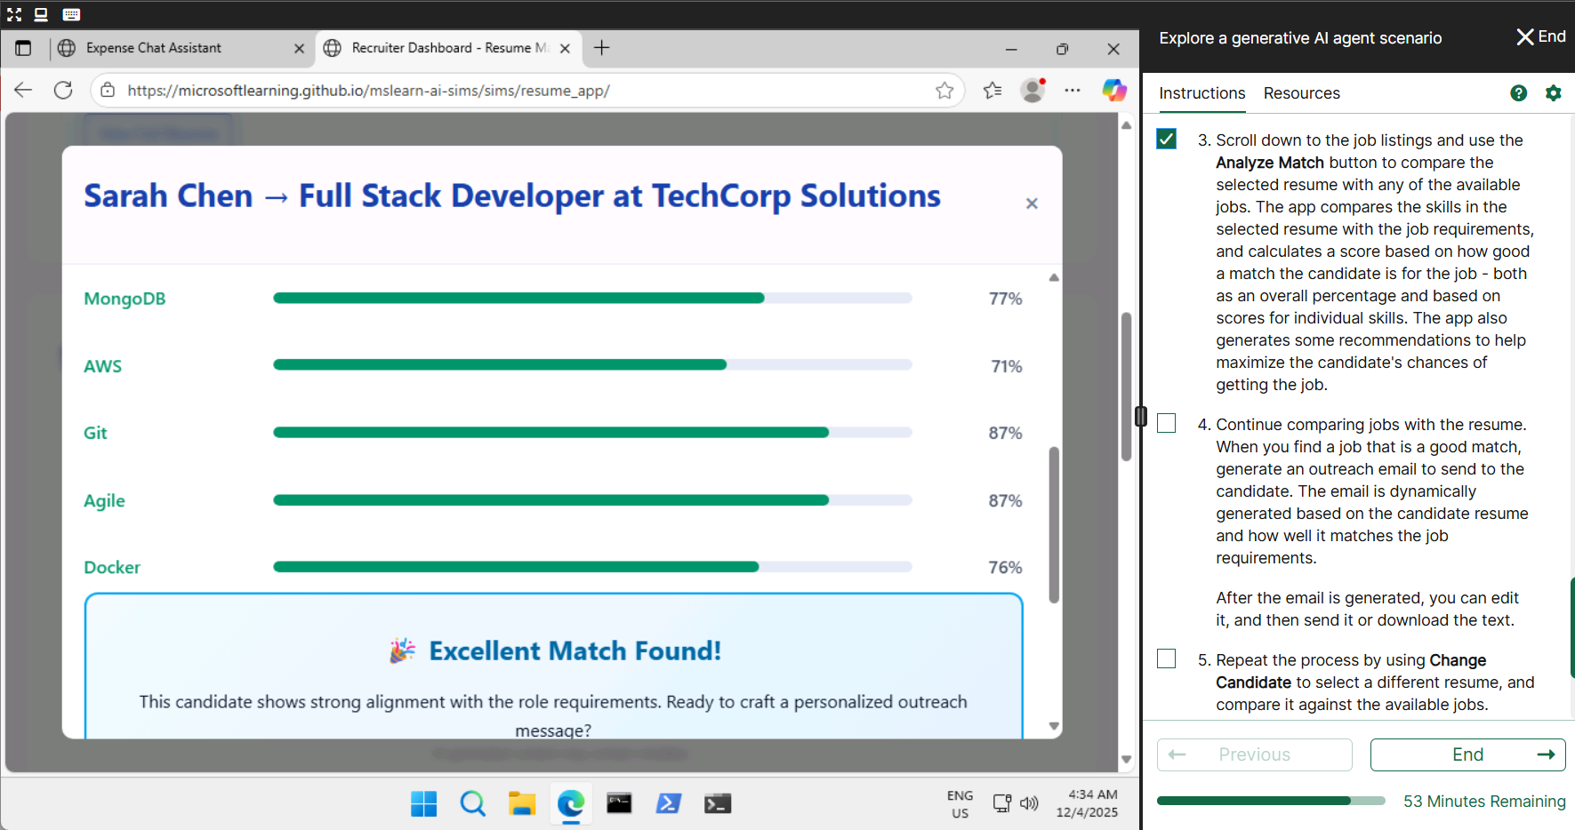

Lab 4 -[Explore generative AI in Azure AI Foundry portal](https://msle.learnondemand.net/Lab/77495?instructionSetLang=en&classId=720986)

Exploring generative AI in Azure email generation

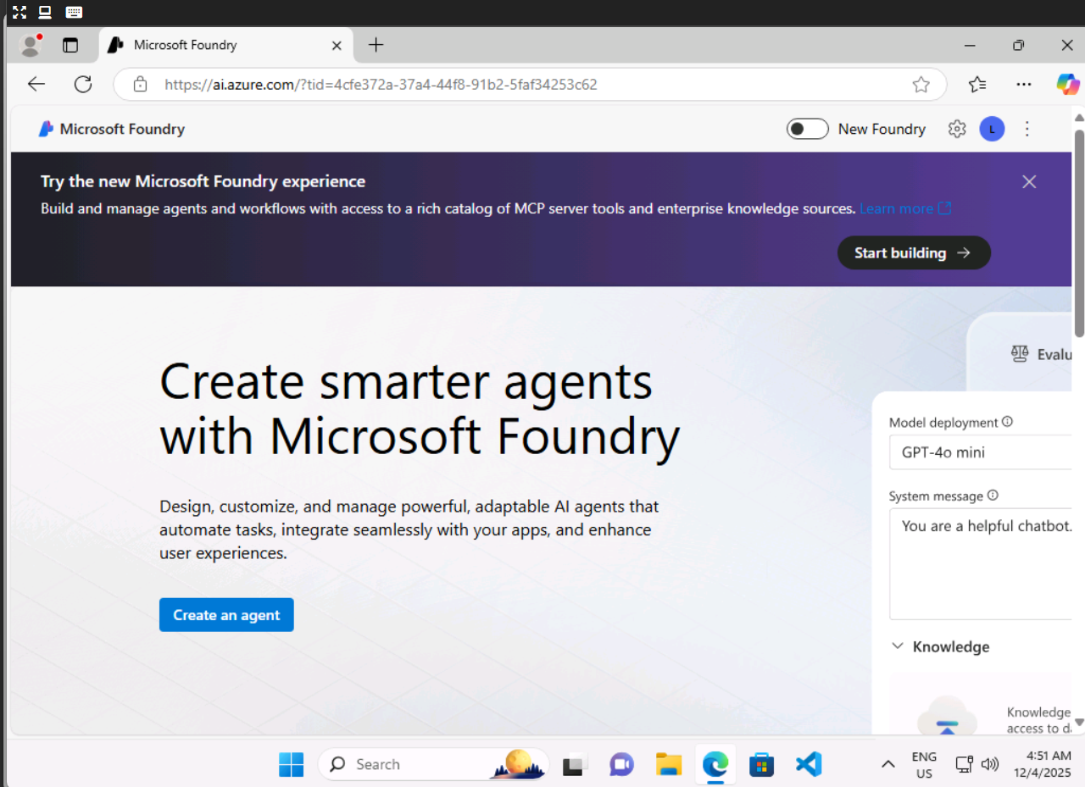

Creating a project using gpt 4.0 model

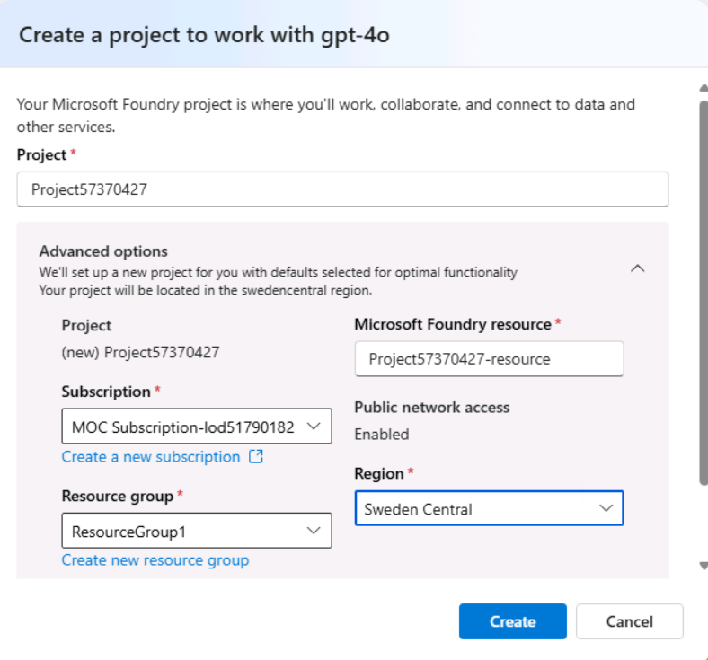

Setting chat playground

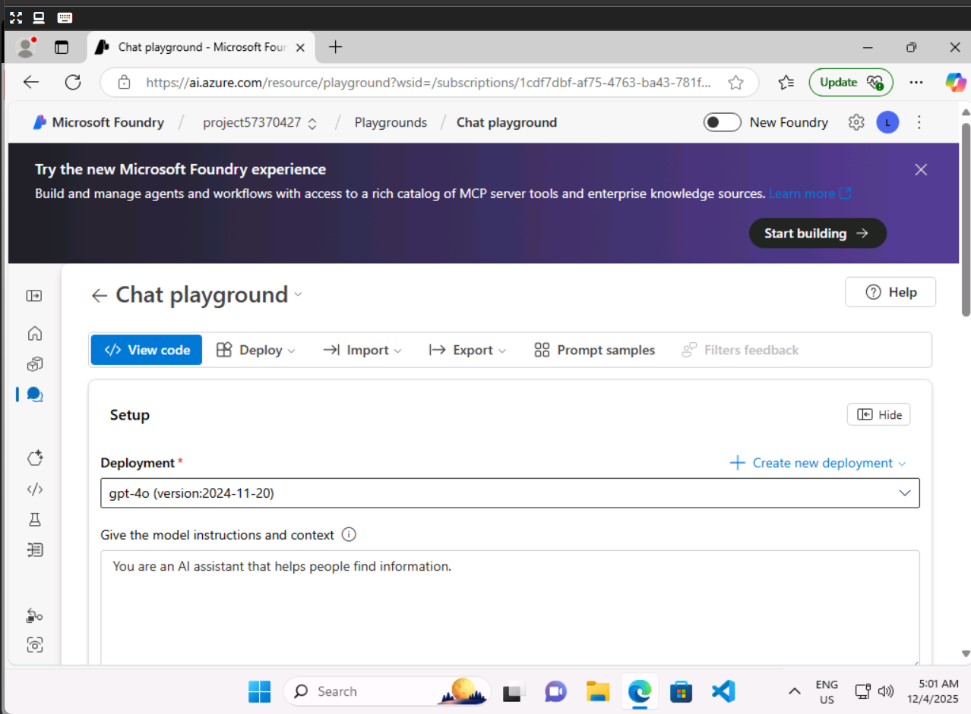Response from the prompt

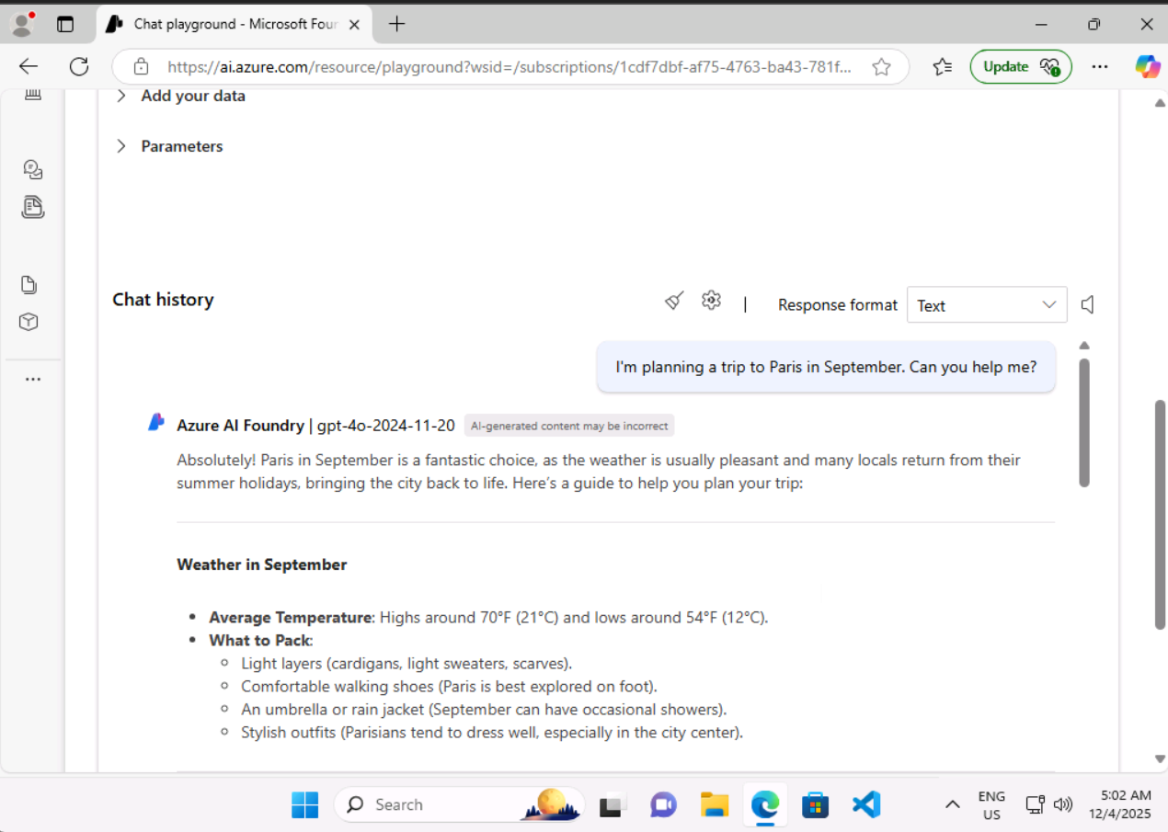Viewing the sample code

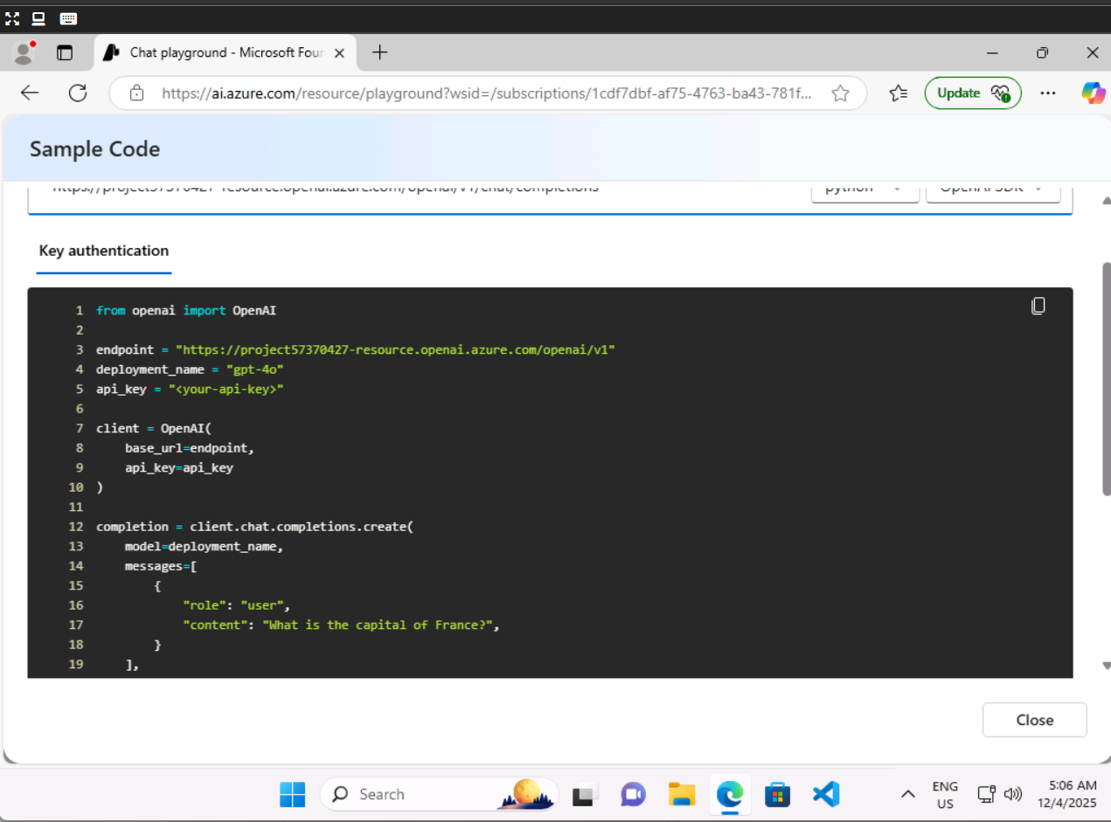Cleaning the resource group

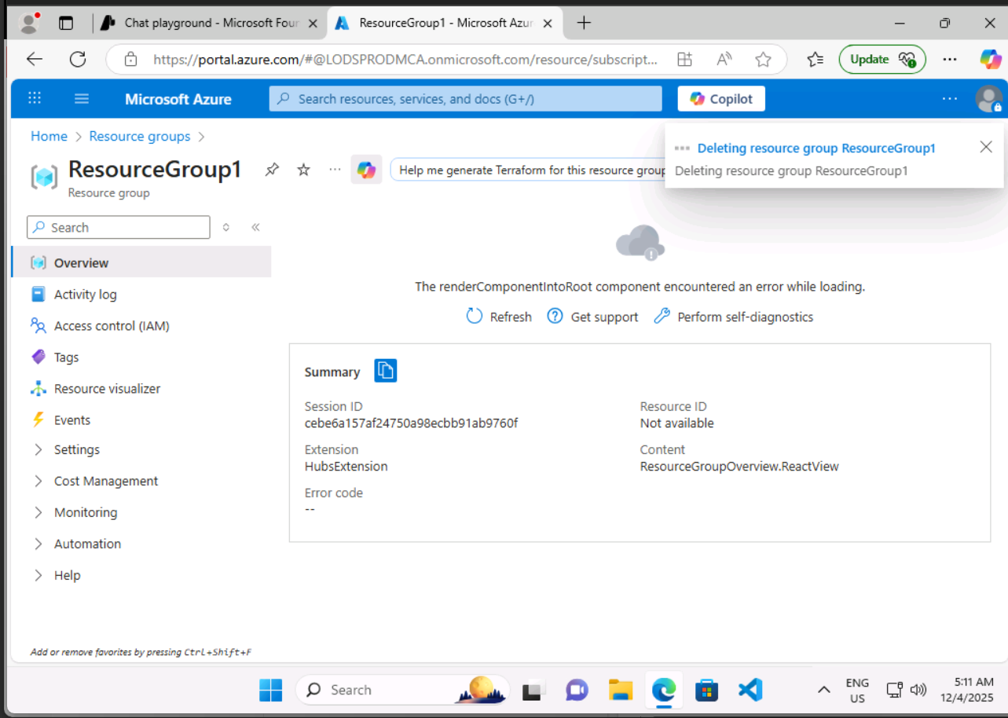

Lab 5 - [Explore a natural language processing scenario](https://msle.learnondemand.net/Lab/77502?instructionSetLang=en&classId=720986)

Analyzing recorded file

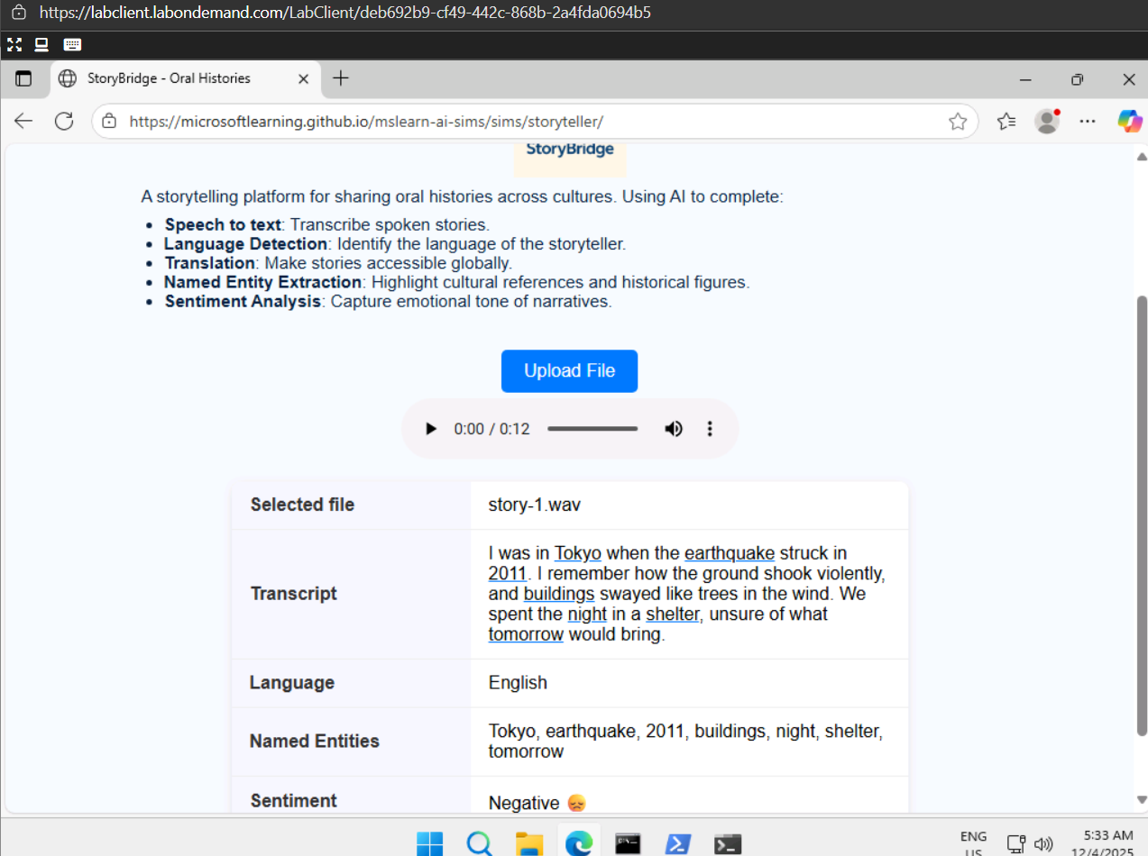Analyzing social media post

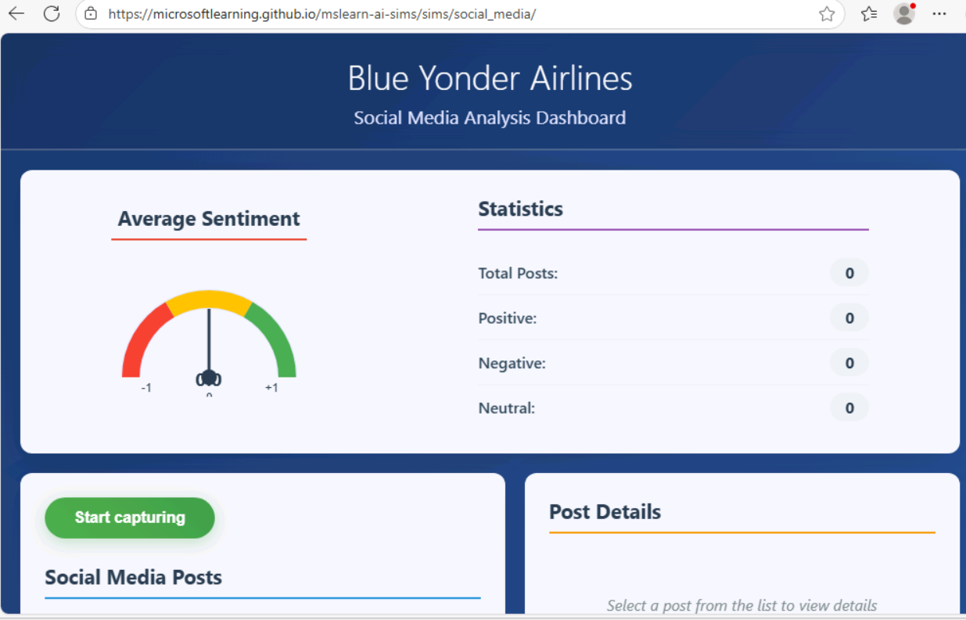shows a details of a running metric of sentiment for social media posts in real-time.

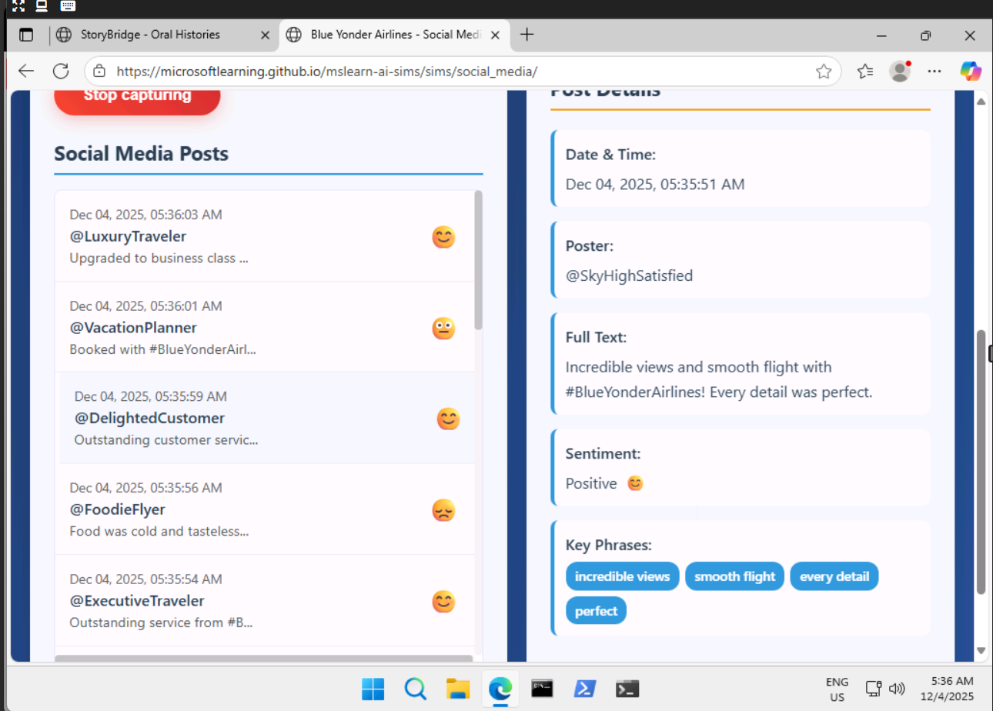

lab 6 –[Analyze text in Azure AI Foundry portal](https://msle.learnondemand.net/Lab/77496?instructionSetLang=en&classId=720986)

we don’t have subscription access to perform these lab

Lab 7- [Explore speech in Azure AI Foundry portal](https://msle.learnondemand.net/Lab/77497?instructionSetLang=en&classId=720986)

we don’t have subscription access to perform these lab

Lab 8 - [Explore a computer vision scenario](https://msle.learnondemand.net/Lab/77503?instructionSetLang=en&classId=720986)

Photo tagger -Analyses the photo and describe about it

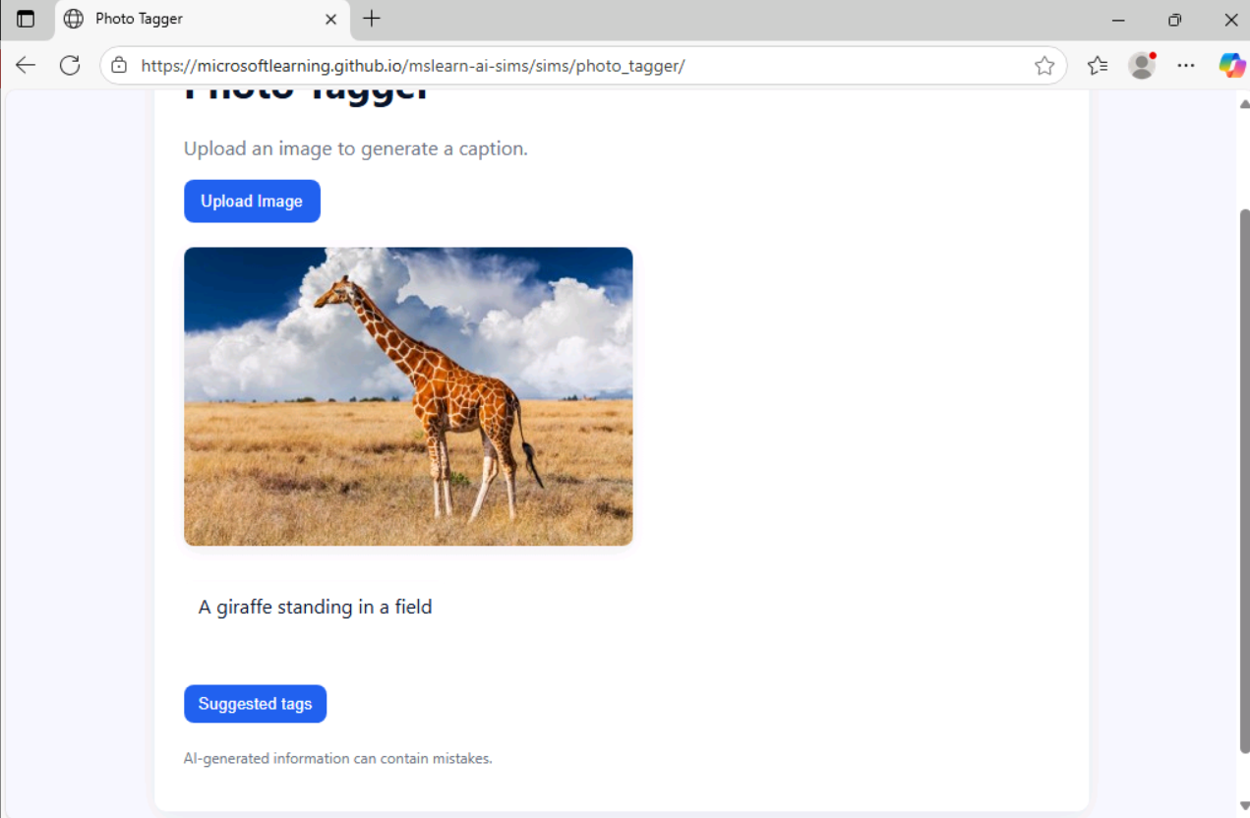

Detecting a human planting a tree in a image

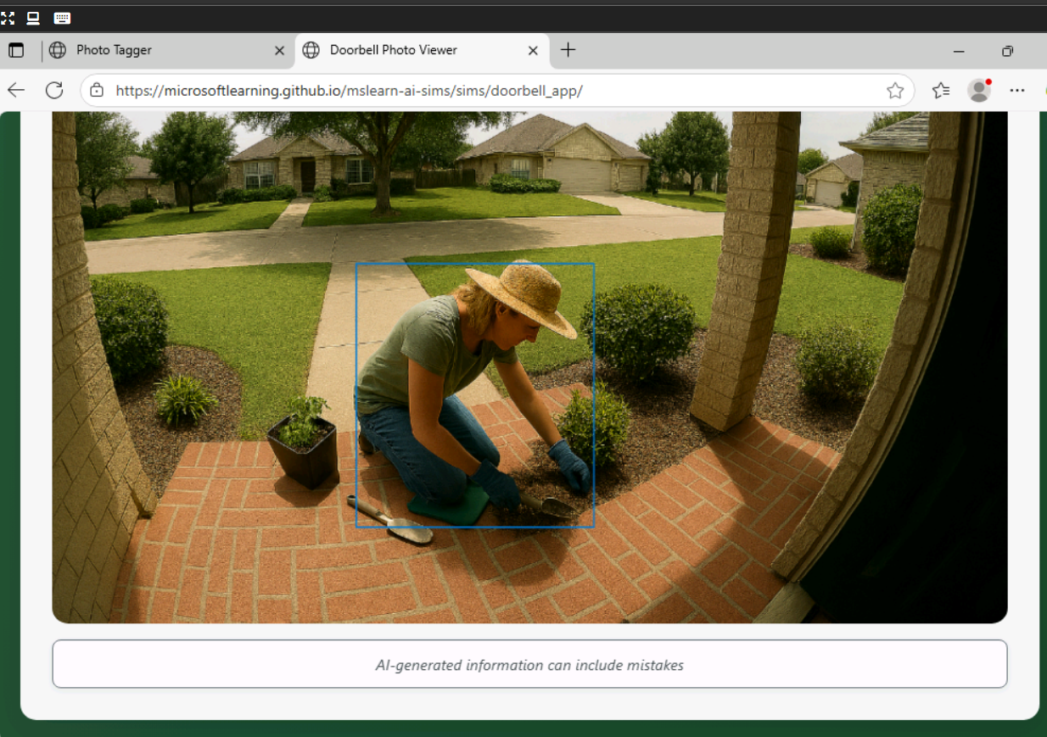

Lab 9 – [Analyze images in Azure AI Foundry portal](https://msle.learnondemand.net/Lab/77498?instructionSetLang=en&classId=720986)

Creating a new hub

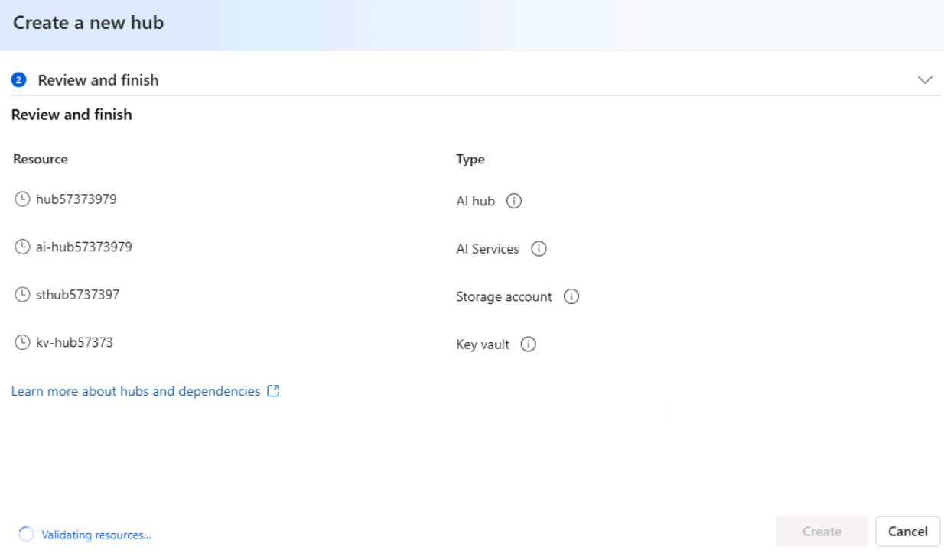Creating a New project

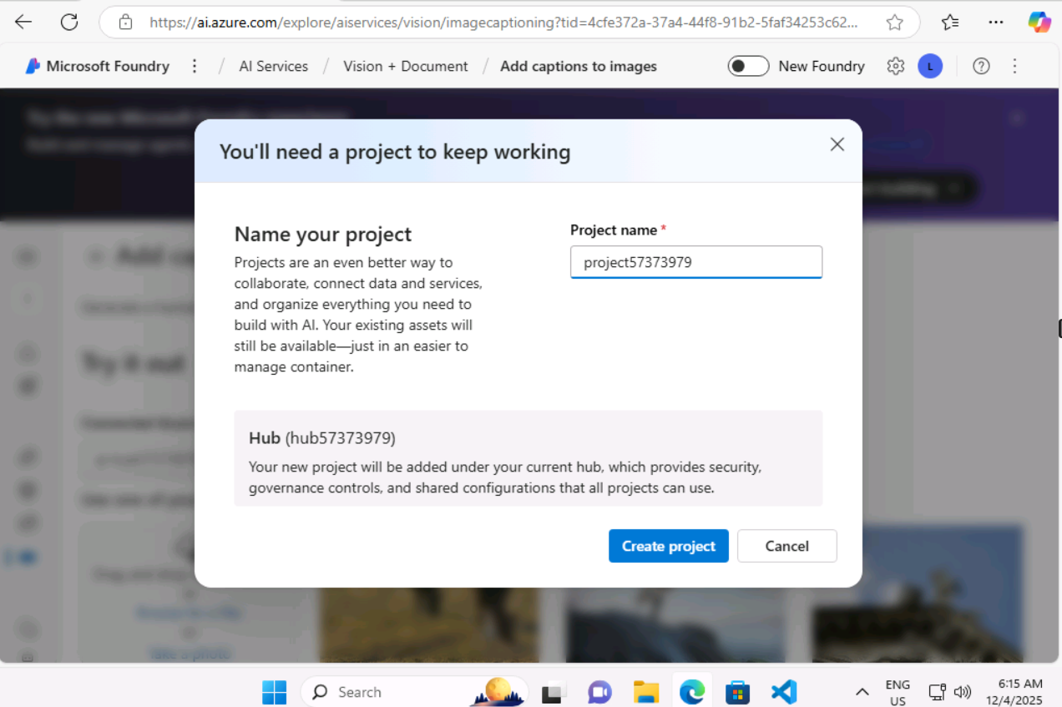description of a image

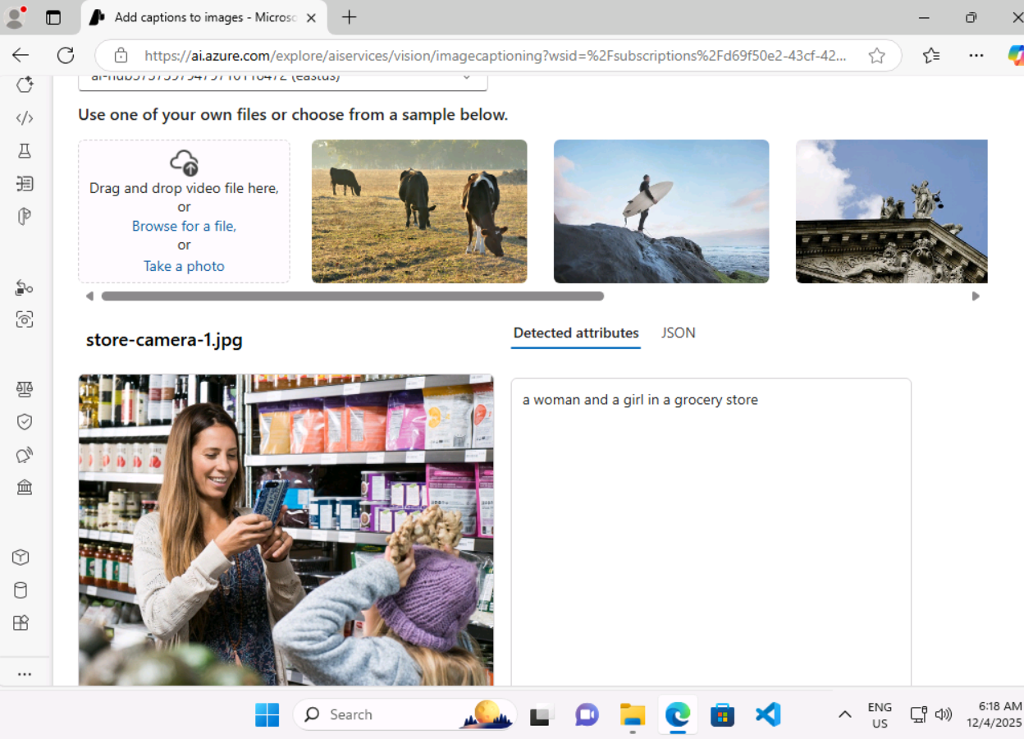Image description by dense captioning

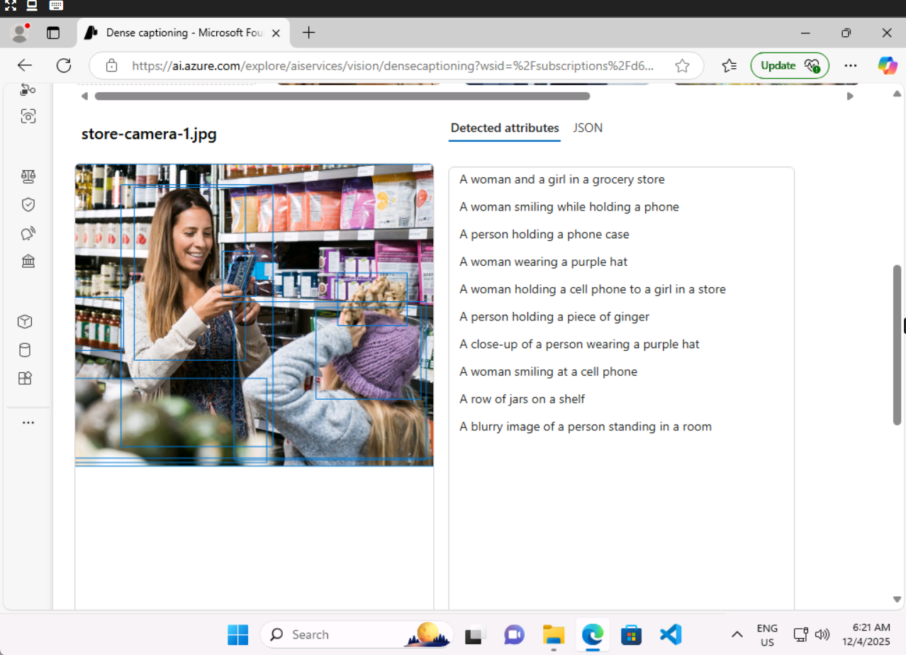Image description by Common tag expression

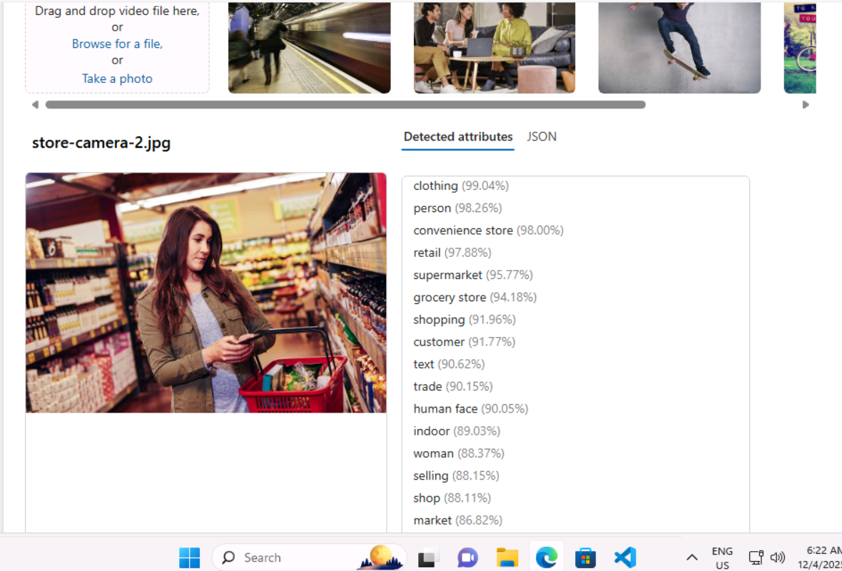Image detection using common object detection

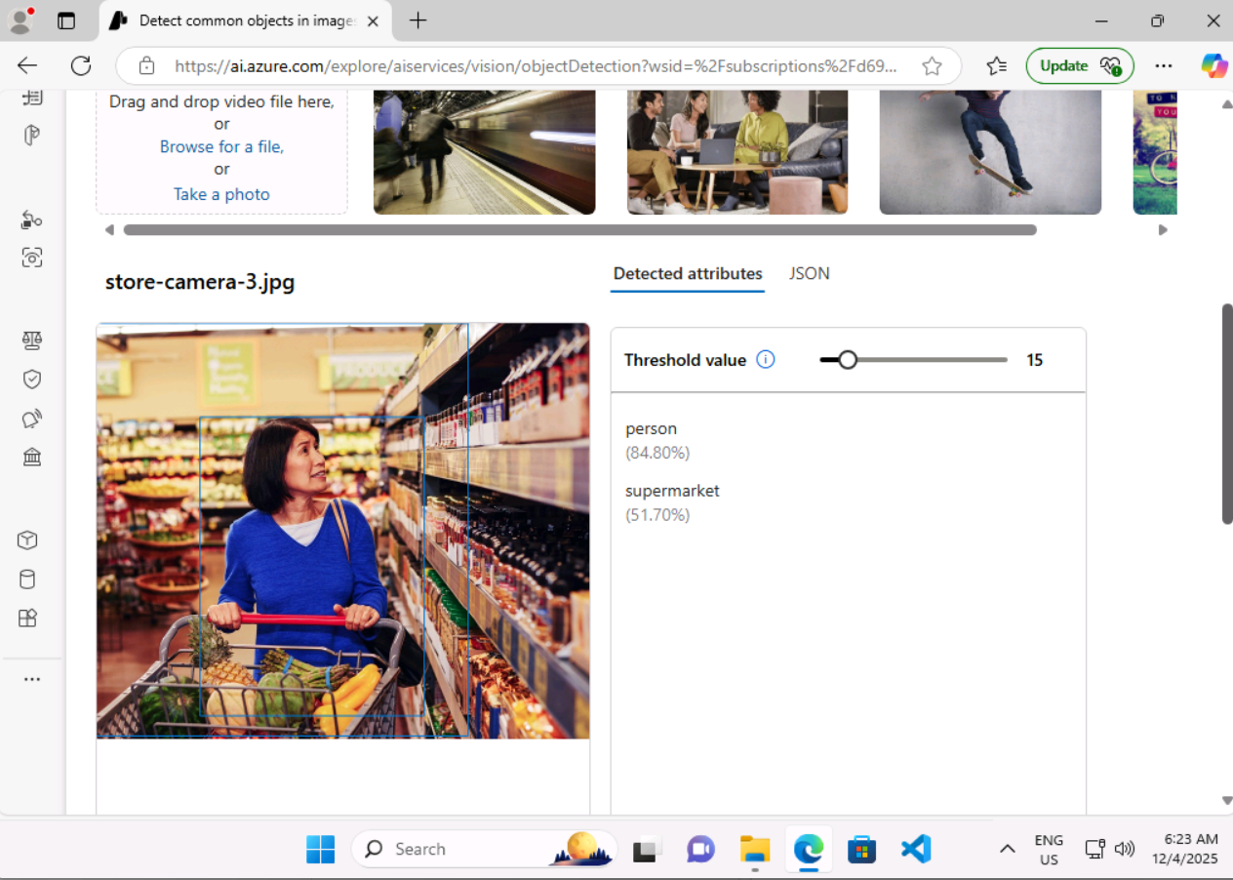Cleaning the resource group

Lab 10 - [Explore an AI information extraction scenario](https://msle.learnondemand.net/Lab/77504?instructionSetLang=en&classId=720986)

Analyzing the reciept

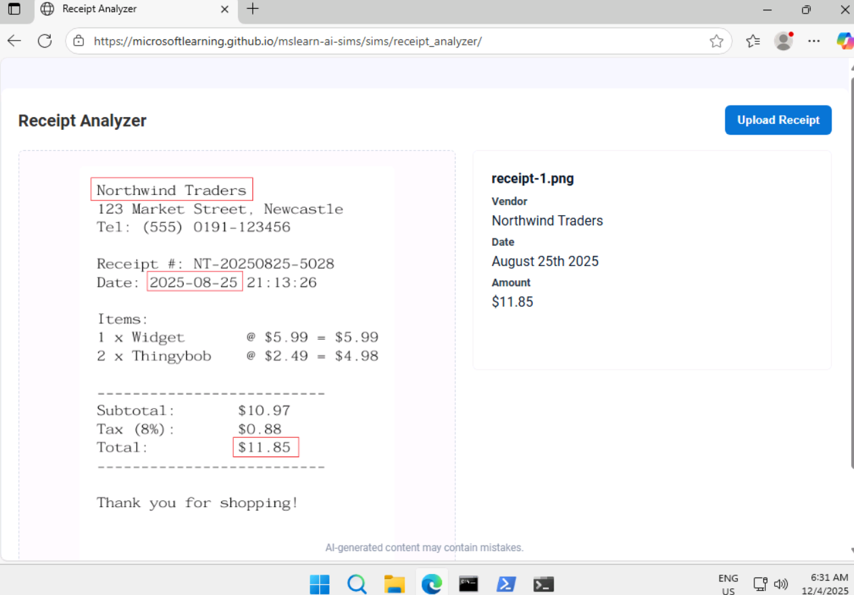

Extracting information from phone calls

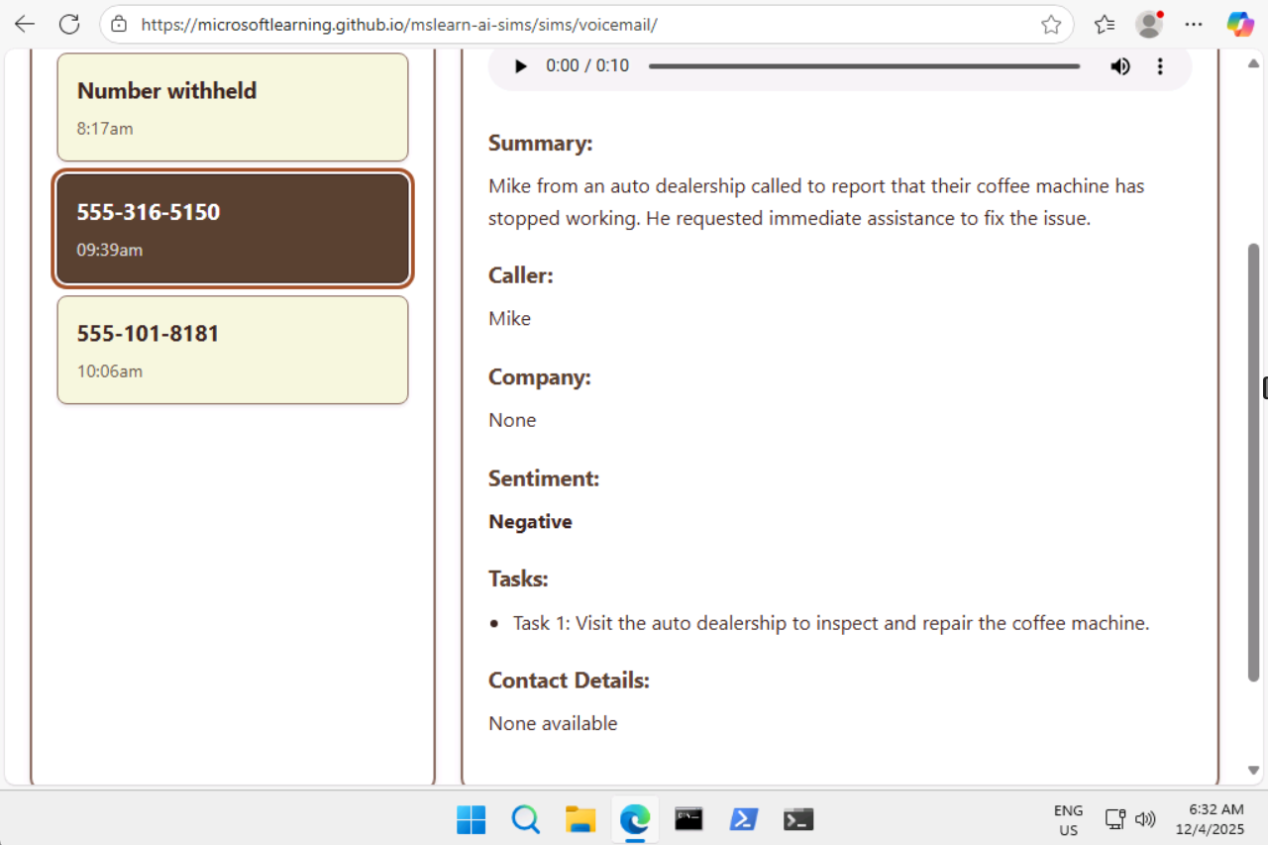

Lab 11- [Extract data with Content Understanding in Azure AI Foundry portal​](https://msle.learnondemand.net/Lab/77499?instructionSetLang=en&classId=720986)

we don’t have subscription access to perform these lab